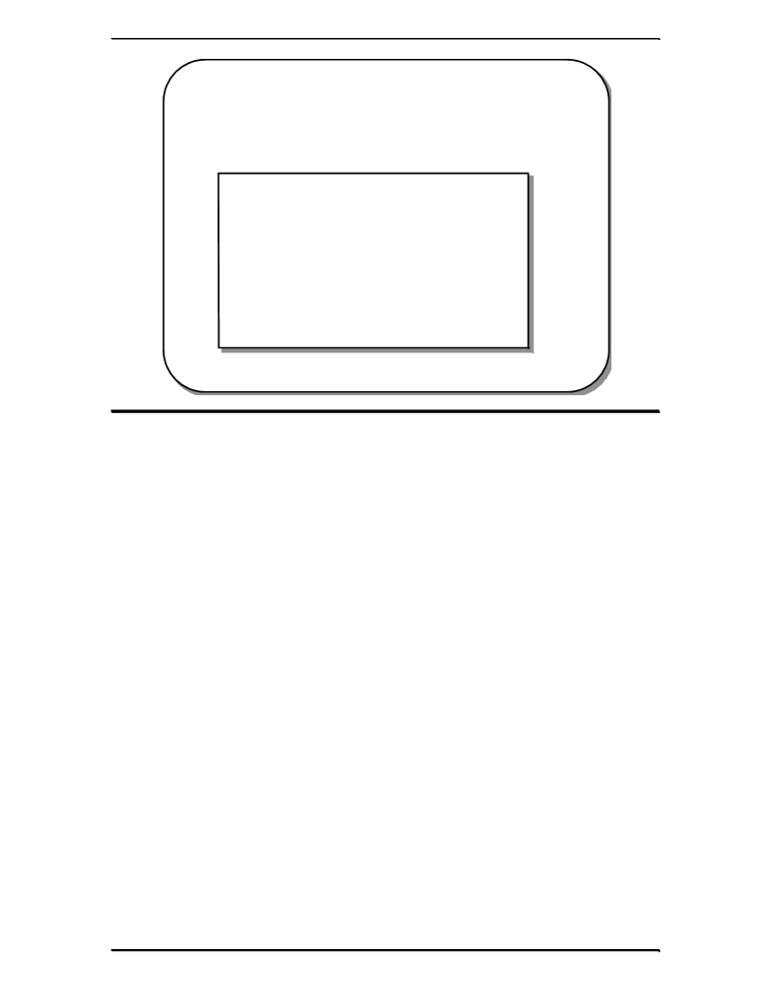
SAMif(cP=='aLE ONLY
NOelseprintf='q')O BE
TRcaserA'c':(cquitoptionNchosen

switch vs. C supports a multi-way decision making construct called switch. The code
if/then/else above is an alternative to the nested if then else construct:
' || c == 'A')
printf("area = %.2f\n", r * r * pi); else if(c == 'c' || c == 'C')
printf("circumference = %.2f\n", 2 * r * pi);

("quit option chosen\n");
else
printf("unknown option chosen\n");

The conditions may be placed in any order:

USswdefprintf("unknownFoptionchose
break;
\n");
ase 'C':

n\n");

printf("circumference = %.2f\n", 2 * r * pi); break;
case 'a': case 'A':
printf("area = %.2f\n", r * r * pi); break;
}

